Experiment No: 01

Experiment Name: Install  Ubuntu 19.04 a LTS along with Windows.

Back Up Your Existing Data:

This is highly recommended that you should take backup of your entire data before start with the installation process.

Obtaining System Installation Media

Download latest Desktop version of Ubuntu from this link: <http://www.ubuntu.com/download/desktop>

**Booting the Installation System**

There are several ways to boot the installation system. Some of the very popular ways are , Booting from a

CD ROM, Booting from a USB memory stick, and Booting from TFTP.

Here we will learn how to boot installation system using a CD ROM.

Before booting the installation system, one need to change the boot order and set CD-ROM as first boot

device.

Changing the Boot Order of a Computers

1. As your computer starts, press the DEL, ESC, F1, F2, F8 or F10 during the initial startup screen.

Depending on the BIOS manufacturer, a menu may appear. However, consult the hardware

documentation for the exact key strokes. In my machine, its DEL key as shown in following screenshot.

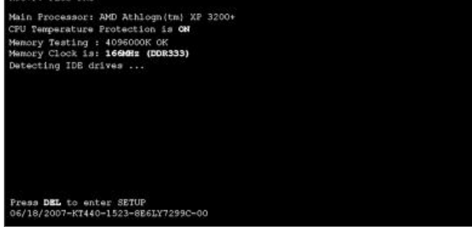

2. Find the Boot option in the setup utility. Its location depends on your BIOS.

Select the Boot option from the menu, you can now see the options Hard Drive, CD-ROM Drive,

Removable Devices Disk etc.

3. Change the boot sequence setting so that the CD-ROM is first. See the list of “Item Specific Help”

in right side of the window and find keys which is used to toggle to change the boot sequence.

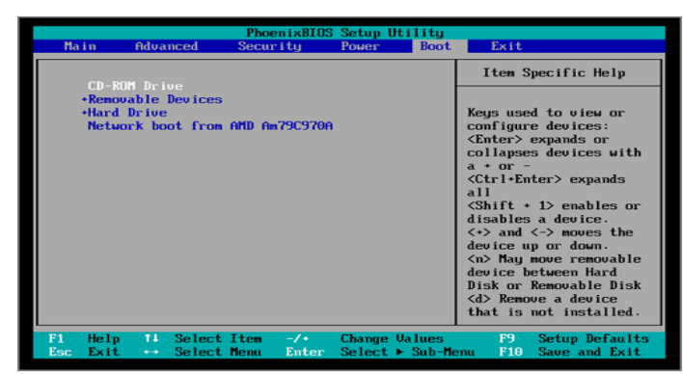

4. Insert the Ubuntu Disk in CD/DVD drive.

5. Save your changes. Instructions on the screen tell you how to save the changes on your computer.

The computer will restart with the changed settings.

Machine should boot from CD ROM, Wait for the CD to load…

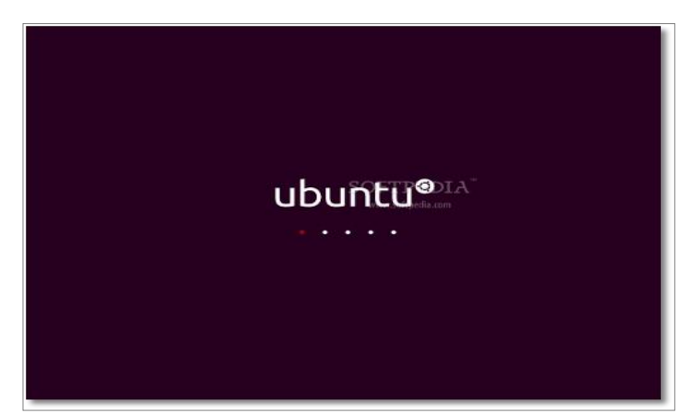

In a few minutes installation wizard will be started. Select your language and click the "Install Ubuntu"

button to continue…

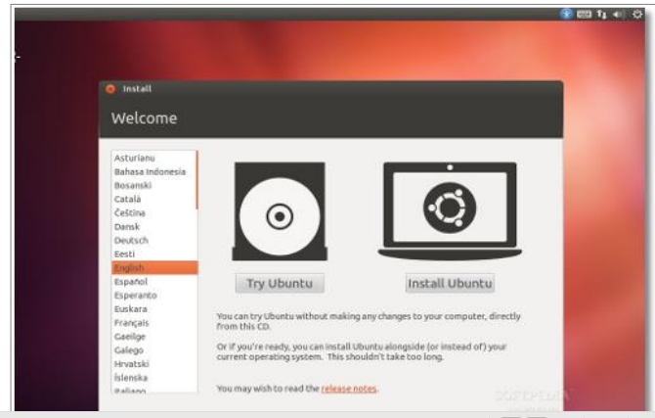

Optionally, you can choose to download updates while installing and/or install third party software, such as

MP3 support. Be aware, though, that if you select those options, the entire installation process will be

longer!

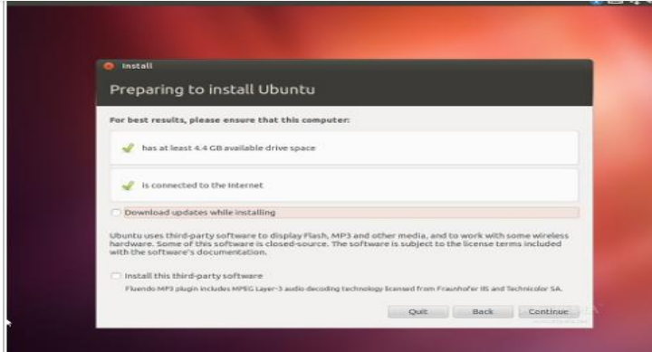

Since we are going to create partitions manually, select Something else, then click Continue. Keep in mind

that even if you do not want to create partitions manually, it is better to select the same option as indicated

here. This would insure that the installer will not overwrite your Windows , which will destroy your data.

The assumption here is that sdb will be used just for Ubuntu 12.04, and that there are no valuable data on

it.

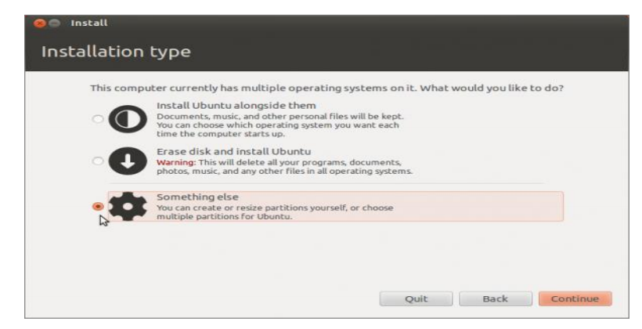

**Where are you?**

Select your location and Click the "Continue" button .

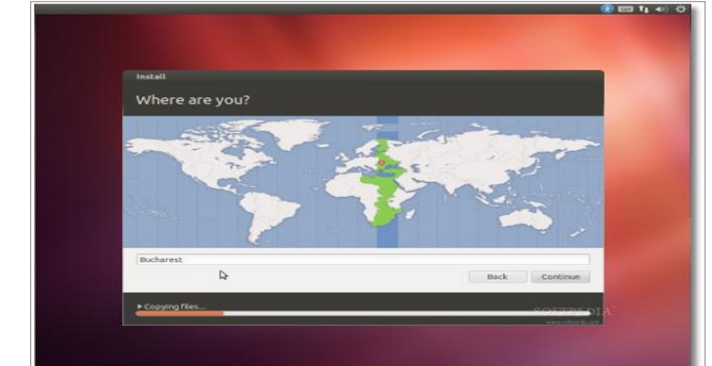

Keyboard layout

Select your keyboard layout and UK (English) and Click on “Continue” button

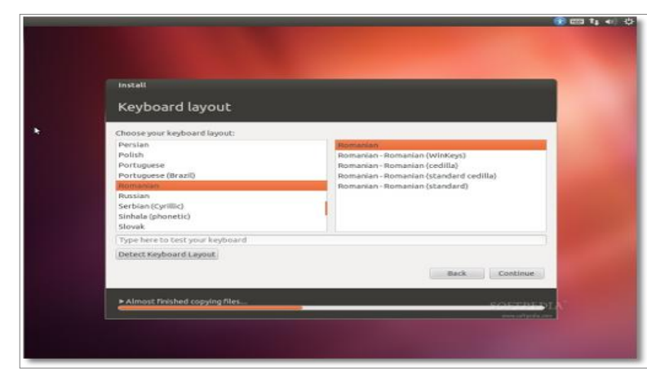

**Who are you?**

Fill in the fields with your real name, the name of the computer username, and the password.

Also at this step, there's an option called "Log in automatically." If you check it, you will automatically be

logged in to the Ubuntu desktop without giving the password.

Click on the "Continue" button to continue…

Now Ubuntu 19.04 a LTS operating system will be installed.

It will take approximately 10-12 minutes (depending on computer's speed), a pop-up window will appear,

notifying you that the installation is complete, and you'll need to restart the computer in order to use the

newly installed Ubuntu operating system. Click the "Restart Now" button.

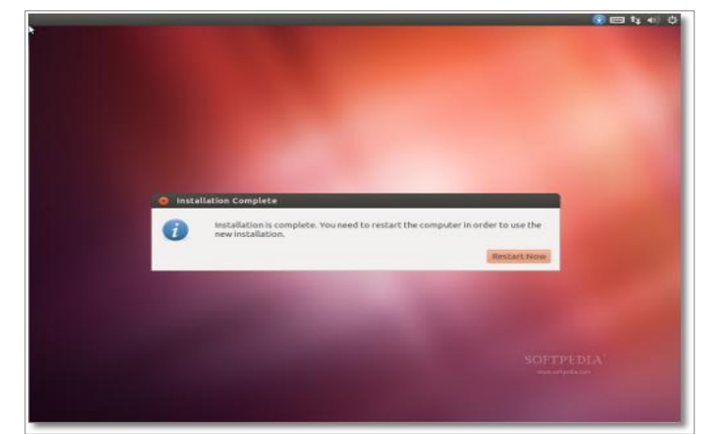

Please remove the CD and press the "Enter" key to reboot. The computer will be restarted. In a few

seconds,

you should see Windows 7′s boot menu with two entires listed – Windows 7 and Ubuntu 12.04 (LTS).

Then you may choose to boot into Windows 7 or  Ubuntu 19.04 a LTS using the UP/Down arrow key.

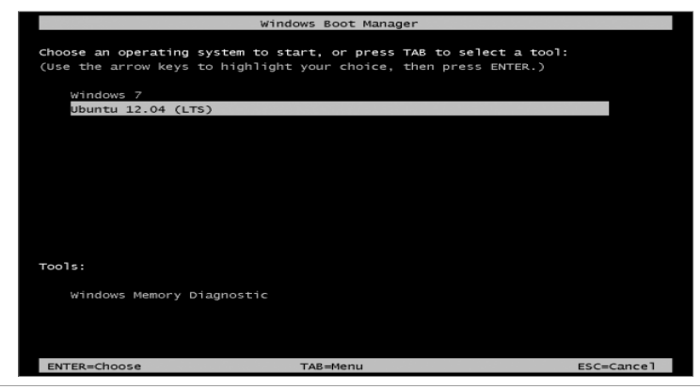

Please select Ubuntu 12.04 (LTS) and press Enter to boot the machine in Ubuntu 12.04 Linux.

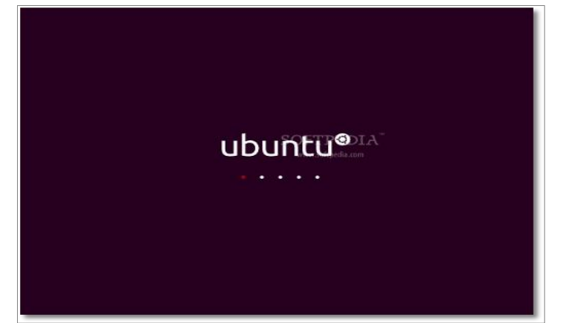

Here you can see the users on the machine, Click on the user name and enter the password and press Enter

key to login.

We have successfully install and login to Ubuntu 12.04 LTS.

**Conclusion:**  Finally i install the linux from the help of online video and different blog . Actually it is  Ubuntu 19.04 a LTS